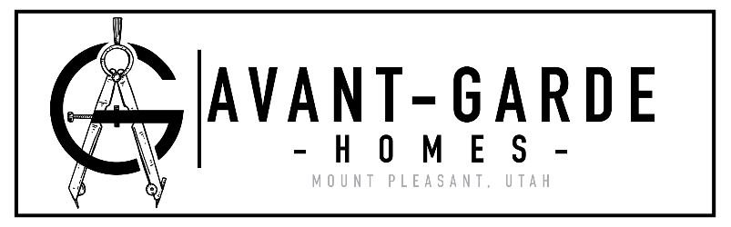**Avant Garde Homes**

1125 S. Blackhawk Blvd.

Office: 435-462-9782

Cell: 435-262-7181

[jstrange@avantgardehomes.net](mailto:jstrange@avantgardehomes.net)

# Project Questionnaire

Project Name-

Location/Address: (please provide the most precise address you can)

Email:

Phone Number:

Rock Retaining Wall: Yes or No

Finished Areas:

Basement: Yes, No, N/A

Main Floor: Yes or No

2nd/Loft: Yes, No, N/A

Excavation:

Sewer or Septic

City water or Well

Propane or Natural Gas

Concrete:

Driveway Size:

Front Porch Size:

Back Porch/Patio Size:

Any special requirements: Yes or No

Framing:

Exterior walls- Stud (2x4 or 2x6), Log

Interior walls- Stud (2x4 or 2x6), Log

Wall/Ceiling Height:

Basement- 8 ft, 9ft, other, N/A

Main- 8 ft, 9ft, other

2nd- 8 ft, 9ft, other, N/A

Vaults: Yes (Specify where) or No

Roofing: Shingle, Metal, Other (Specify other)

Exterior:

Siding: (Vinyl or Fiber Board)

Brick: Yes (provide height below) or No

Front Height-

Right height-

Left Height-

Back Height-

Stucco: Yes or No

Stone: Yes (provide height below) or No

Front Height-

Right height-

Left Height-

Back Height-

HVAC:

Furnace: Natural gas, Propane, Electric

Range: Natural gas, Propane, Electric

Dryer: Natural gas, Propane, Electric

BBQ Connection: Yes or No

Fireplace: Natural gas, Propane, Wood, Pellet, N/A

Extra Connections: Yes or No

Plumbing:

Water Heater (40 gal., 50 gal., or on demand) Electric, natural gas, propane

Tub: Fiberglass one piece, Freestanding, cultured marble surround, Tile surround, or other (specify other)

Master-

Main-

Others-

Shower: Fiberglass one piece, cultured marble surround, Tile surround, or other (specify other)

Master-

Main-

Others-

Toilets: Round bowl, Elongated bowl, or ADA (elongated taller bowl)

Faucets:

Handle: Moen single handle or Moen double handle

Style: Chateau (Cheapest option), Brantford, or Eva

Finish-

Chateau comes in chrome only

Brantford comes in Brushed nickel, Oil rubbed bronze, and Chrome

Eva comes in Brushed nickel, Oil rubbed bronze, and Chrome

Bathroom Sinks: Oval china, Square, or other (specify other)

Undermount- Yes or No

Kitchen Sink: Stainless Steel, Farm, or other (specify other)

Undermount- Yes or No

Disposal- ½ hp disposal (Yes or No)

Water Softener: Yes or No

Electrical:

Ceiling Fan count

Can lighting general locations

Windows: Low E, Double Pane

Trim Color: White or Other (specify other)

Grids: Yes or No

Privacy Glass: Yes or No

Insulation:

Basement: Batt, Continuous Blanket, or Blow-in System

Above ground Floors: Batt or Blow-in System

Attic: R38 (code) or R50

Extra for Sound: Yes (specify where) or No

Garage Door(s):

Steel or Other (specify other)

Windows: Yes or No

Insulated: Yes or No

Interior Covering:

Walls: Sheetrock or T&G

Ceiling: Sheetrock or T&G

Garage: Sheetrock (Yes or No)

Trim:

Baseboard-3.25”, 6” MDF, stain grade or other

Trim- 2.25”, 4”, stain grade MDF or other

Crown Molding: Yes or No

Window casing: Yes or No

Interior Doors: Hollow core, Solid, or other

Front Door:

Sidelights: Yes or No

Door Hardware finish: Antique Nickel, Satin Nickel, Brass, Brushed Nickel, or Oil Rubbed Bronze

Paint:

We will bid all living areas (I.E. finished basement, main level, 2nd floor, etc.) as three tone.

Garage Area: One tone, Clear Coat, Firetape, N/A

Cabinets:

Material: Alder, Oak, Hickory, White or Other (specify other)

Height: Standard, Tall or other

Countertop: Granite, Solid Surface or Laminate

Flooring: Tile, Carpet, Wood, Laminate, Vinyl